Week 7 Assignment Report
Data Cleaning with Pandas & Incremental Processing with Delta Lake
Tools used: Python, Pandas, PySpark, Delta Lake, Databricks

1. Objective
The objective of this Week 7 assignment is to build a small but complete data engineering workflow that covers two stages of a real pipeline: cleaning raw data with Pandas, and then loading that cleaned data into Delta Lake to practice incremental (upsert) processing using the MERGE operation. The idea is to simulate what actually happens in a company when a new batch of data — containing both updated and brand-new records — needs to be merged into an existing table without duplicating or overwriting good data by mistake.
By the end of this assignment, the following skills were practiced:
- Reading, exploring and cleaning a CSV file using Pandas
- Handling missing values sensibly instead of just dropping everything
- Creating a derived column from existing columns
- Loading data into a Delta Table using PySpark on Databricks
- Performing an incremental load using the Delta Lake MERGE INTO command
- Validating the final dataset for row count and duplicate records

2. Introduction
Every data pipeline starts with raw data, and raw data is almost never clean. In this assignment, the starting point was a customer purchase dataset (customer_master.csv) containing customer details, the product purchased, price and quantity. This file intentionally had a few missing values and duplicate rows, similar to what happens in real systems due to manual entry errors, failed uploads, or repeated syncs.
The first part of the assignment used Pandas, which is the standard Python library for working with tabular data on a single machine. Pandas is good for small to medium datasets and is usually the first step before moving to a distributed tool, and it is also the easiest way to get a quick feel for a dataset before writing any bigger pipeline code.
The second part moved into Databricks and PySpark, since that is what large-scale data engineering pipelines actually use in production. Instead of just overwriting the whole table every time new data arrives, this assignment focused on incremental processing, meaning only the changed or new records are processed, which is far more efficient for big datasets. In a real company, tables can have millions of rows, so reloading everything every day is simply not practical — incremental loading using MERGE is the standard way around this.
This report walks through both parts step by step, in the same order they were done in the notebook, followed by a deeper explanation of the MERGE operation, validation checks, and what was learned along the way.

3. Tools and Technologies Used
The following tools and technologies were used to complete this assignment. Each one plays a different role in the overall workflow, from initial data cleaning to the final incremental load.
- Python – the base programming language used for the entire assignment
- Pandas – used in Part 1 for reading, exploring and cleaning the raw CSV file
- PySpark – the Python API for Apache Spark, used in Part 2 to work with larger-scale, distributed data
- Delta Lake – the storage layer used on top of Spark to get transaction support and the MERGE feature
- Databricks – the platform where the PySpark and Delta Lake code is actually meant to run, using Databricks Volumes to store the CSV files
- Jupyter Notebook – used to write and document the code in a step-by-step, explained format
Together, these tools represent a fairly typical (if simplified) data engineering stack: a lightweight tool for initial cleaning, and a distributed engine with a transactional storage layer for the actual pipeline work.

4. What is Delta Lake?
Delta Lake is an open-source storage layer that sits on top of regular Parquet files and adds a transaction log on top of them. This transaction log is what gives Delta Lake its most useful properties, especially for data engineering work:
- ACID transactions – so a write either fully succeeds or fully fails, there is no half-written table
- Schema enforcement – prevents accidentally writing data with the wrong column types
- Time travel – older versions of a table can be queried using a version number or timestamp
- Upserts using MERGE – lets us update existing rows and insert new rows in one single operation
Compared to just writing plain CSV or Parquet files, Delta Lake is much safer for pipelines where the same table is updated repeatedly over time, which is exactly the situation this assignment is simulating.

5. Explanation of Tasks Performed
The table below summarises every task that was carried out in the notebook, along with the tool used and the result of that step.
# | Task | Tool Used | Outcome
1 | Load raw CSV | Pandas | Data loaded into DataFrame
2 | Explore dataset | head, tail, info, describe | Understood shape and datatypes
3 | Handle missing values | fillna, dropna | No nulls remaining
4 | Filter & select columns | Boolean indexing | Subsets created
5 | Remove duplicates | drop_duplicates | Duplicate rows removed
6 | Create total_amount | price * quantity | New column added
7 | Save cleaned CSV | to_csv | cleaned_customer.csv created
8 | Load into Delta Table | PySpark + Delta | Delta table created
9 | Create incremental file | Pandas | customer_incremental.csv created
10 | MERGE operation | Delta MERGE INTO | Old records updated, new inserted
11 | Validation | count(), groupBy | Row count & duplicates verified

4.1 Loading and Exploring the Dataset
The raw dataset was loaded using pandas.read_csv() and explored using head(), tail(), shape, columns, info() and describe(). This step is important because it tells us the size of the data, which columns have missing values, and whether the numeric columns look reasonable (for example, no negative prices).
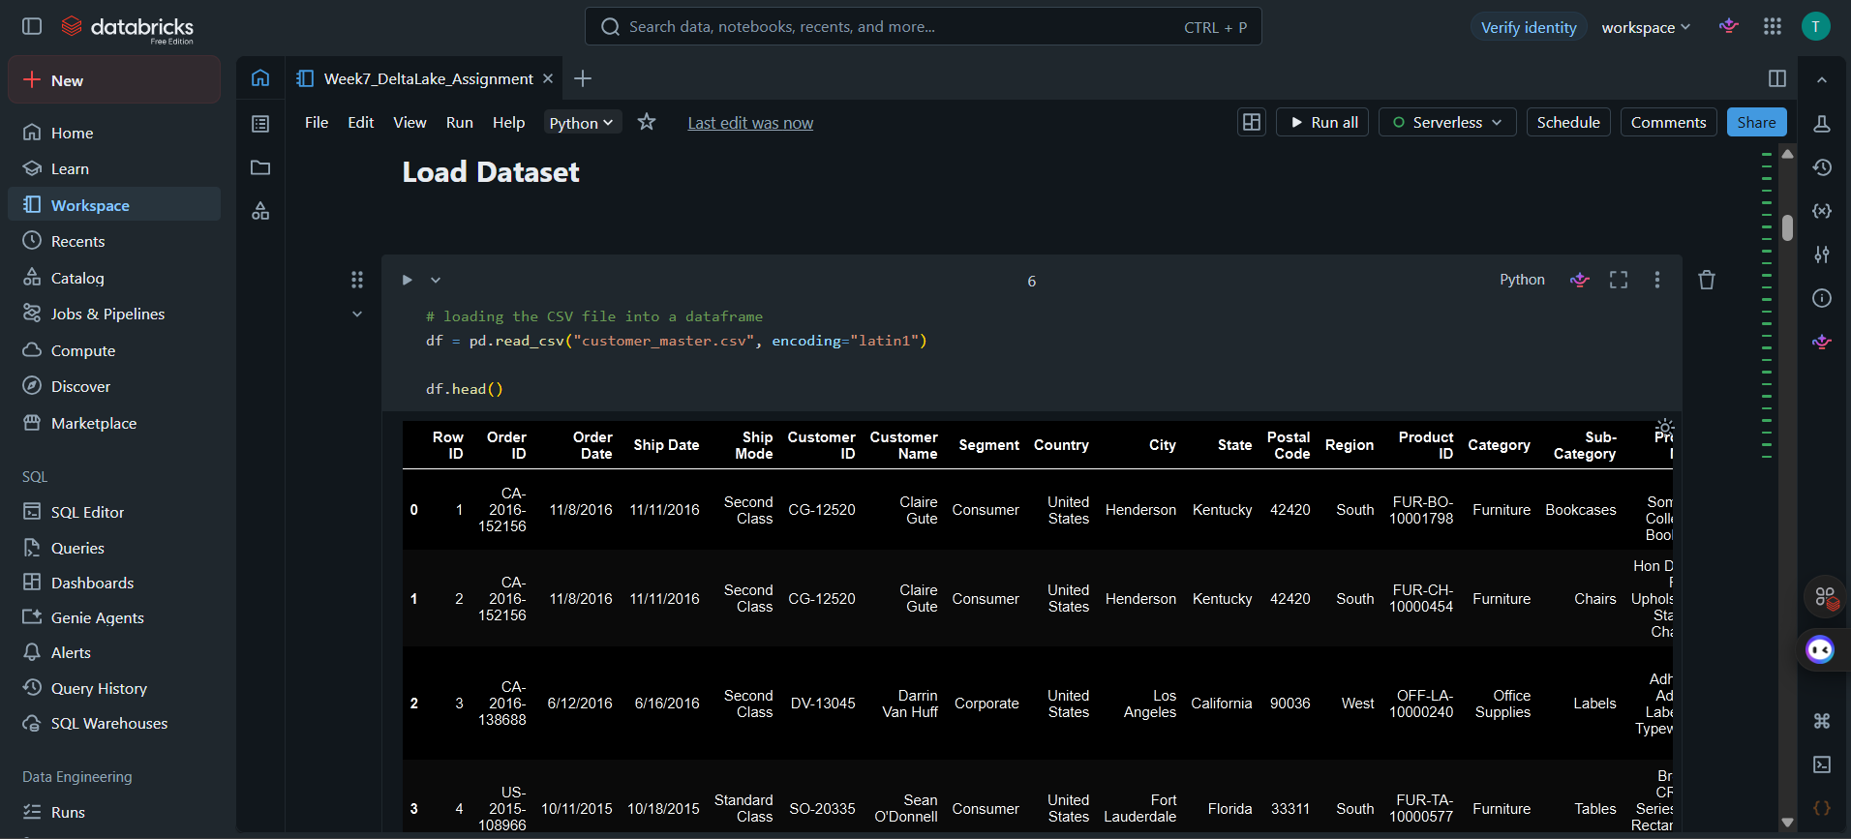
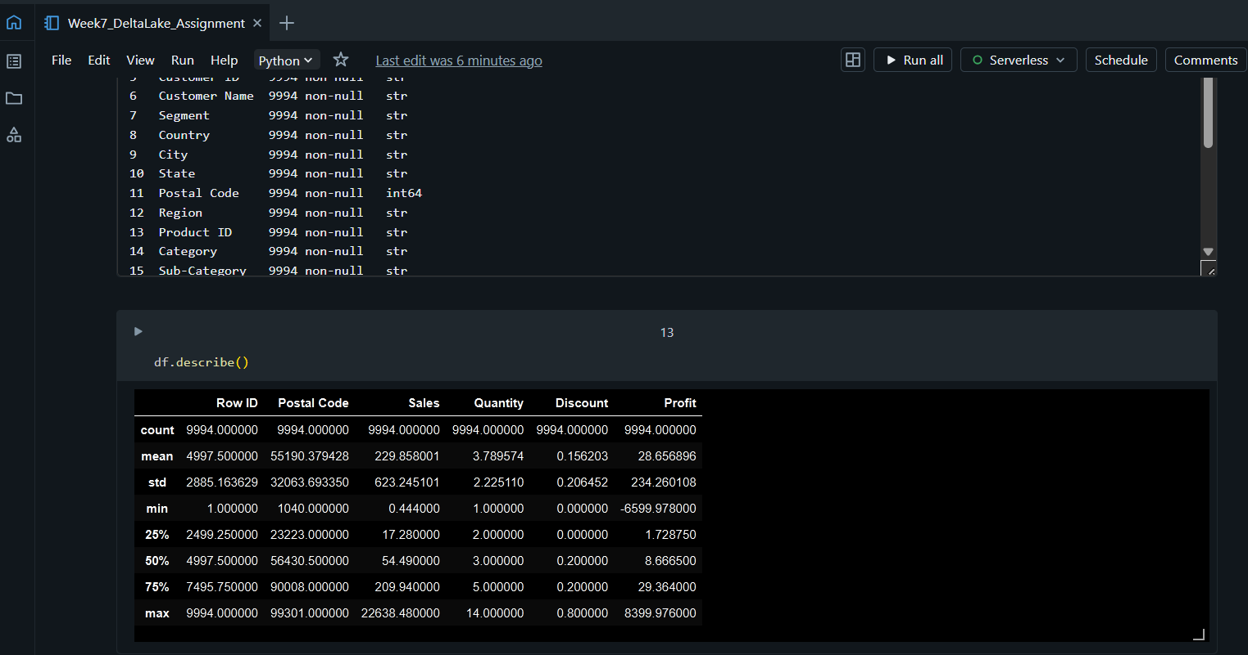

4.2 Handling Missing Values
Different columns were handled differently instead of applying one rule to the whole dataset. Text columns like city and email were filled with placeholder values since dropping those rows would lose useful purchase data. Rows with a missing price were dropped, because total_amount cannot be calculated without a price. Missing quantity values were filled with 1, assuming at least one unit was purchased.
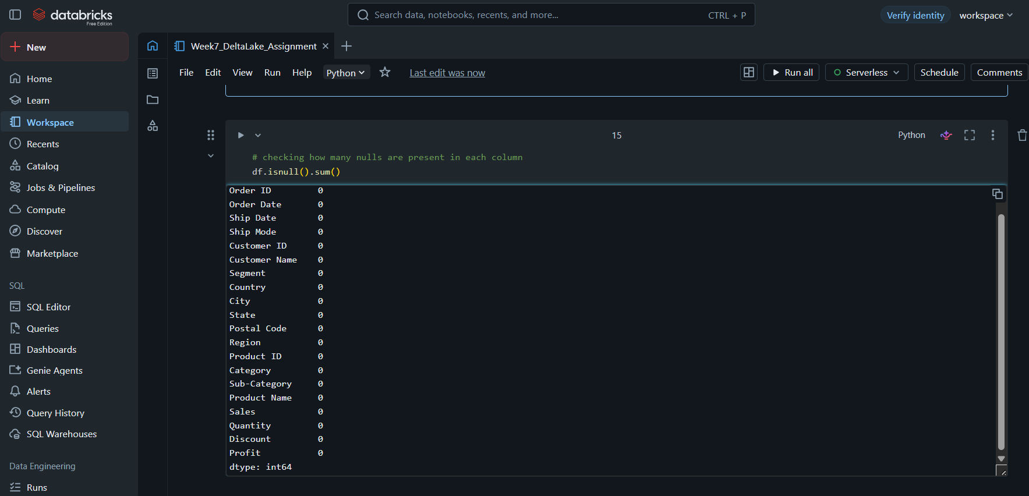

4.3 Removing Duplicates and Creating the Derived Column
Exact duplicate rows were removed using drop_duplicates(). After that, a new column total_amount was created by multiplying price and quantity, which is a simple but common example of feature/column derivation in data engineering.
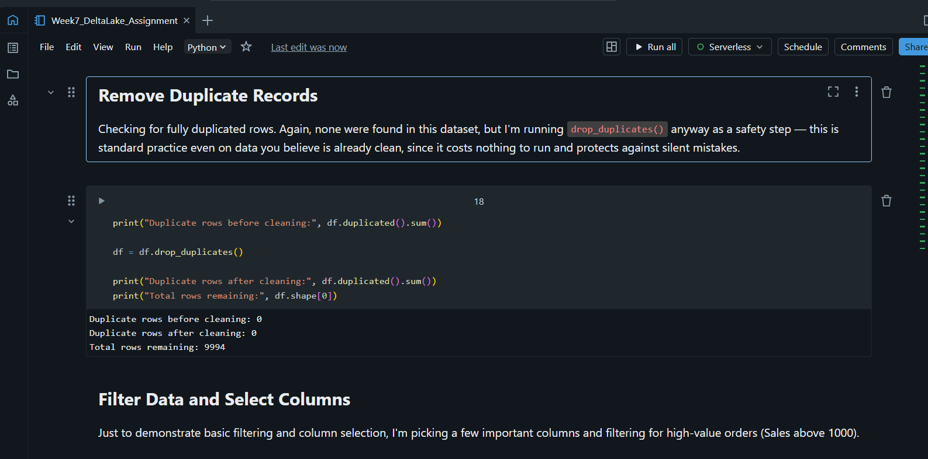

4.4 Loading Data into a Delta Table
The cleaned CSV (cleaned_customer.csv) was read using PySpark and written out as a Delta Table using the .format("delta") option, with the file assumed to be uploaded to a Databricks Volume path. Writing in Delta format instead of plain CSV means the table now has a transaction log, which is what makes the MERGE step possible.
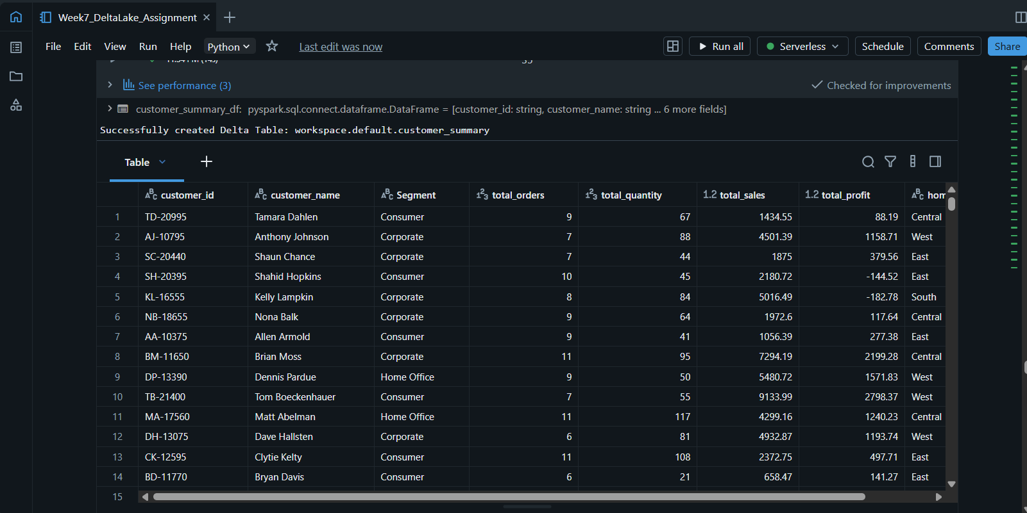

4.5 Creating the Incremental Dataset
A second file, customer_incremental.csv, was created to simulate a new daily batch of data. It has two types of rows: six existing customers whose price and quantity changed (representing updated records), and five brand-new customers who were not present in the original table (representing new records).
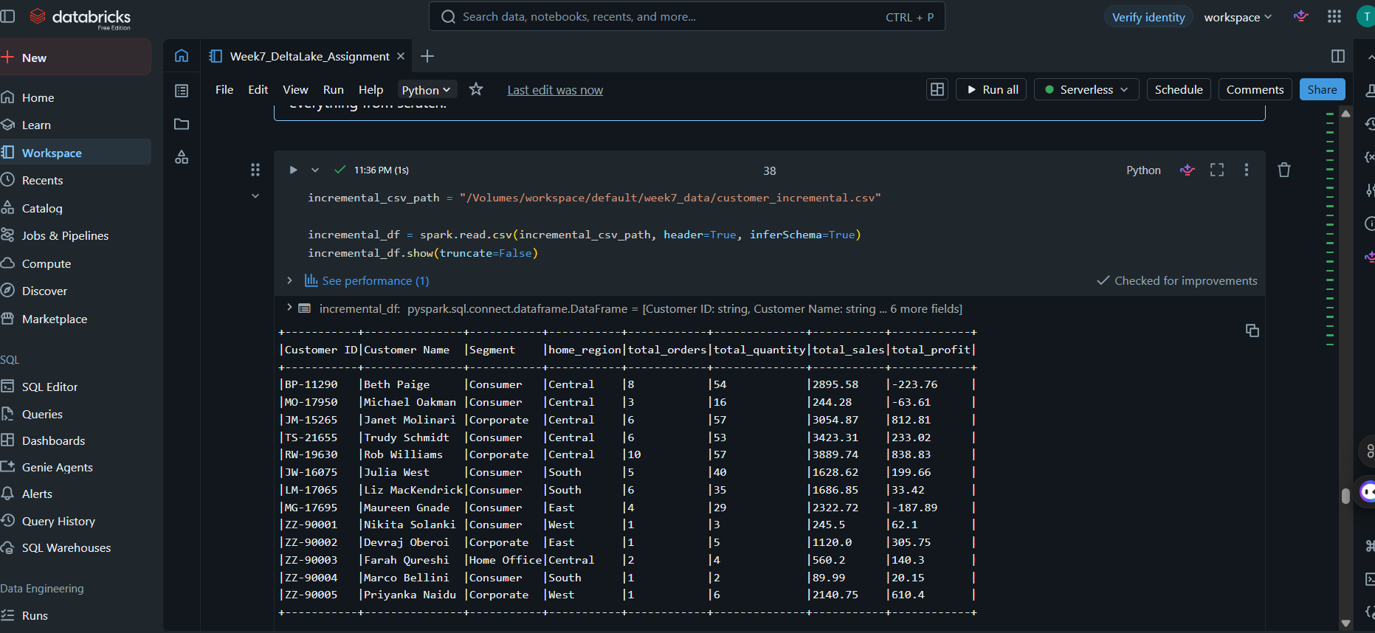

6. Understanding the MERGE Operation
MERGE INTO is the core feature that was practiced in this assignment. Instead of writing separate logic to figure out which rows are new and which rows already exist, MERGE handles both cases in a single command, based on a matching condition — in this case, matching on customer_id.

5.1 Why MERGE is used
Without MERGE, updating a table incrementally would normally require reading the whole table, comparing it row by row against the new data in code, and then writing everything back — which is slow and error-prone for large tables. MERGE lets Delta Lake do this comparison internally and only touch the rows that actually need to change.

5.2 What happens during UPDATE
When a customer_id from the incremental file already exists in the Delta table, the matching row is updated in place — the price, quantity, and total_amount columns are replaced with the new incoming values. No new row is added for this case.

5.3 What happens during INSERT
When a customer_id from the incremental file does not exist in the Delta table, MERGE simply inserts it as a completely new row. This is how the five new customers (2001–2005) were added to the table.

5.4 Before and After Example
The table below shows what happens to one existing customer (customer_id 1002) before and after the MERGE, based on a price and quantity update coming in from the incremental file.
Field | Before MERGE (old value) | Incoming record | After MERGE (final value)
customer_id | 1002 | 1002 | 1002
customer_name | Priya Patel | Priya Patel | Priya Patel
price | 14000 | 15000 | 15000
quantity | 2 | 3 | 3
total_amount | 28000 | 45000 | 45000

7. Validation
After running MERGE, two checks were done to make sure the operation worked correctly:
- Row count check – confirming the final row count equals the original row count plus the number of genuinely new customers (updates don't add rows)
- Duplicate check – grouping by customer_id and confirming no customer_id appears more than once after the merge
Both checks passed, which confirms that the MERGE only updated the matching rows and only inserted the truly new ones, without creating any duplicate customer records.
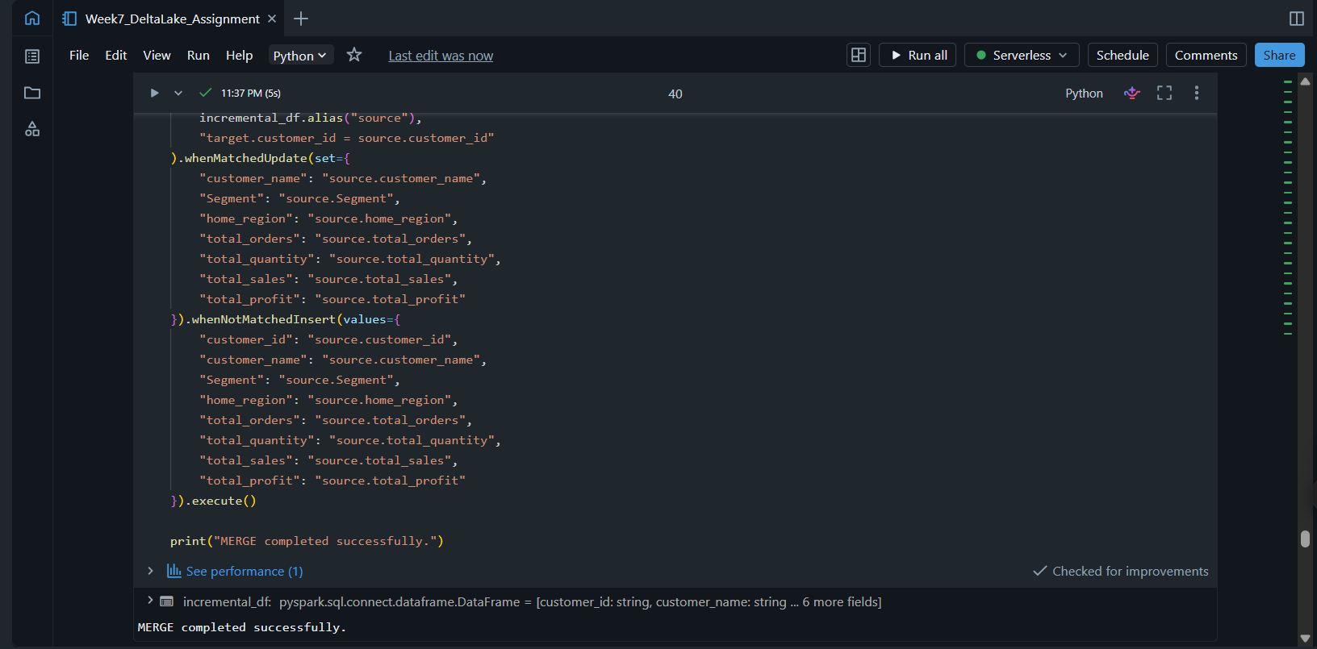

8. Final Output
The final Delta table, sorted by customer_id, was displayed as the last step to visually confirm that both the updated and newly inserted records look correct.
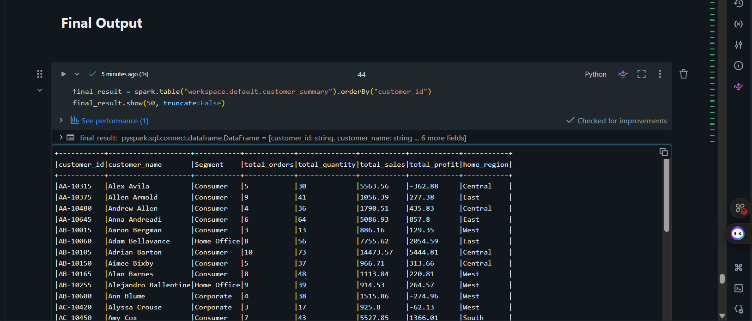

9. Challenges Faced
A few small issues came up while working through this assignment, and it was useful to think through how to solve them instead of just skipping past:
- Deciding how to handle each missing value column separately, instead of applying one blanket rule (like dropna() on the whole dataframe), took a bit of thought — dropping every row with any missing value would have thrown away good purchase data just because the city field was blank.
- Making sure the incremental file actually tested both MERGE cases properly — it needed a mix of existing customer_ids (for updates) and completely new customer_ids (for inserts), so the file had to be built carefully rather than just randomly.
- Remembering that Delta Lake operations need to run inside a Spark/Databricks environment, not a plain Python environment, since regular pandas code cannot create or merge Delta tables.
- Getting the MERGE condition right — using customer_id as the matching key, since that is the unique identifier that stays the same even when other fields like price change.

10. Observations
- Cleaning the data properly before loading it into Delta Lake made the MERGE step much simpler, since there were no null values or duplicates to worry about at that stage.
- MERGE INTO is far less code than manually writing UPDATE and INSERT logic separately, and it reduces the chance of mistakes.
- Validating row counts and duplicates after every load is a simple habit that catches most mistakes early, before they affect downstream reports.
- Delta Lake behaves very similarly to a normal database table, which makes it easier to reason about compared to plain CSV/Parquet files.

11. Learning Outcomes
This assignment helped connect the Pandas-based cleaning work from earlier weeks to an actual Databricks/Delta Lake workflow, which is closer to how real data engineering pipelines are built. The key takeaways were:
- How to clean a dataset thoughtfully instead of applying the same rule to every column
- How Delta Lake improves on plain file-based storage using transaction logs
- How MERGE INTO combines UPDATE and INSERT logic into a single reliable operation
- The importance of validating data after every major transformation step

12. Conclusion
Overall, this assignment gave good hands-on practice with a mini end-to-end pipeline — starting from a messy CSV file, cleaning it with Pandas, and then using Delta Lake's MERGE feature to simulate a real incremental load. The most useful part was seeing how MERGE avoids duplicate records automatically, since that is a common problem when working with data that arrives in batches over time. This workflow (clean → load → merge → validate) is something that can be reused for future assignments involving larger or more frequently updated datasets.

